Data Structures and Algorithms
Exercise 2: E-commerce Platform Search Function
Product.java:
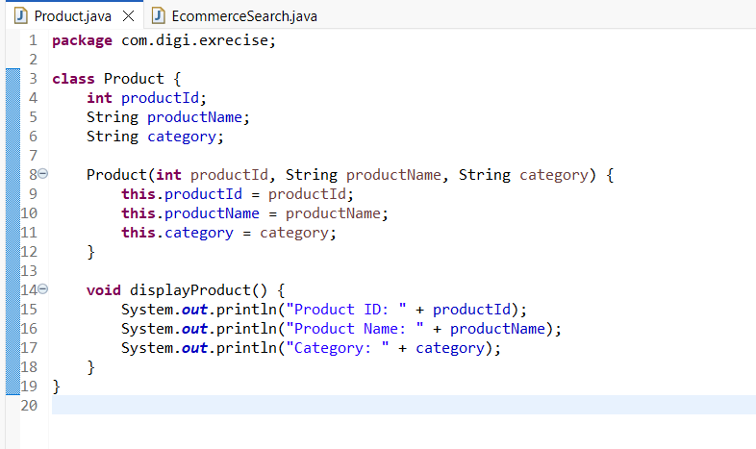
EcommerceSearch.java:
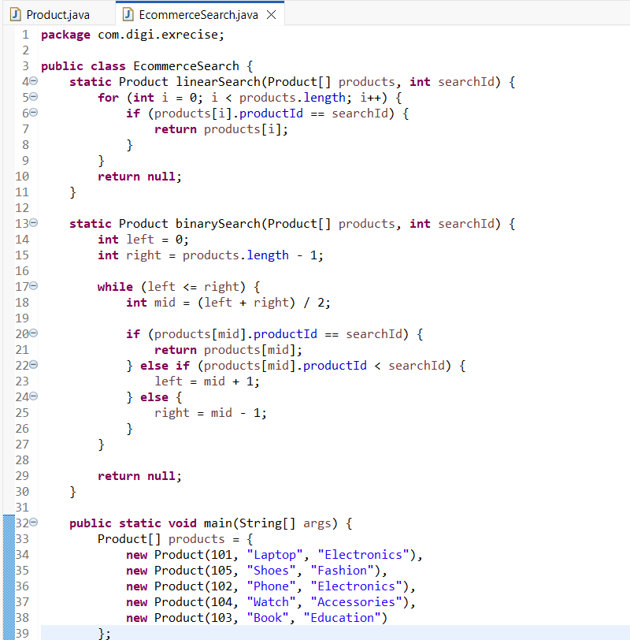
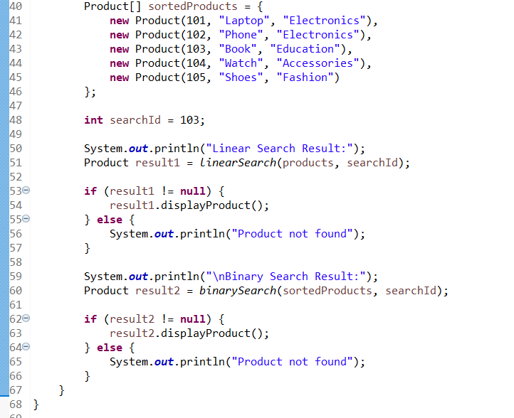
Output:
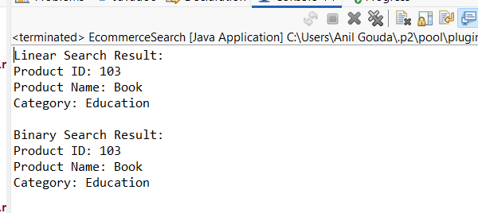

Analysis:
Time complexity:
Linear Search:
- Best case: O(1)
- Worst case: O(n)
- Average case: O(n)
Binary Search:
- Best case: O(1)
- Worst case: O(log n)
- Average case: O(log n)

For an e-commerce platform, binary search is more suitable because products are usually large in number. Linear search checks products one by one, so it becomes slow when there are many products. Binary search is faster because it repeatedly divides the search area into half. But binary search works only when the product array is sorted.

